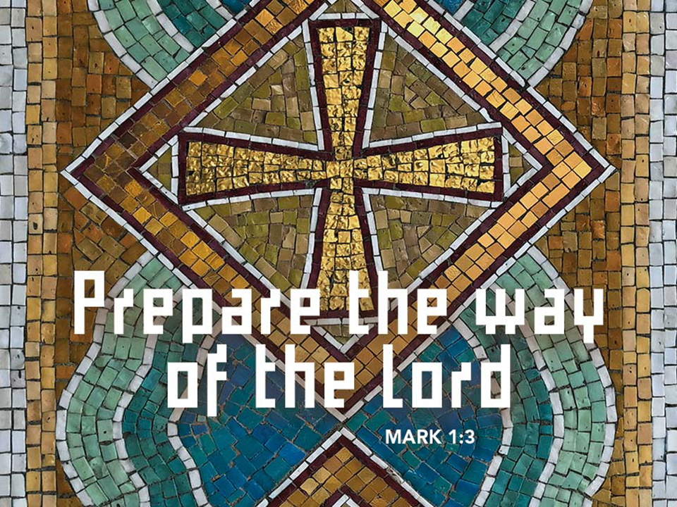
Complete Worship Folder

December 6, 2020

ASCENSION LUTHERAN CHURCH

8695 Gratiot Road Saginaw, MI 48609 (989)781-2170

Email address: ascensionlc@sbcglobal.net

Julie Bailey, Pastor

Sunday Worship 8:00am & 10:30am

Wednesday Worship 7:00pm

Second Sunday of Advent December 6, 2020
Welcome and Announcements

Lighting of Advent Wreath
We praise you, O God, for this circle of light that marks our days of preparation for Christ’s advent.
As we light the candles on this wreath, kindle within us the fire of your Spirit, that we may be light shining in the darkness. Enlighten us with your grace, that we may welcome others as you have welcomed us.
Grant this through Christ our Lord, whose coming is certain and whose day draws near.
Amen.

Opening Ourselves up to Advent (confession—from S/S-video- 6:21)

Greeting
P: The grace of our Lord Jesus Christ, the love of God, and the communion of the Holy Spirit be with you all.
C: And also with you.

Prayer of the Day
P: Let us pray... Stir up our hearts, Lord God, to prepare the way of your only Son. By his coming strengthen us to serve you with purified lives; through Jesus Christ, our Savior and Lord, who lives and reigns with you and the Holy Spirit, one God, now and forever.
C: Amen.

First Reading: Isaiah 40:1-11
¹Comfort, O comfort my people,
says your God.
²Speak tenderly to Jerusalem,
and cry to her
that she has served her term,
that her penalty is paid,
that she has received from the Lord’s hand
double for all her sins.
³A voice cries out:
“In the wilderness prepare the way of the Lord,
make straight in the desert a highway for our God.
⁴Every valley shall be lifted up,
and every mountain and hill be made low;
the uneven ground shall become level,
and the rough places a plain.
⁵Then the glory of the Lord shall be revealed,
and all people shall see it together,
for the mouth of the Lord has spoken.”
⁶A voice says, “Cry out!”
And I said, “What shall I cry?”
All people are grass,
their constancy is like the flower of the field.
⁷The grass withers, the flower fades,
when the breath of the Lord blows upon it;
surely the people are grass.
⁸The grass withers, the flower fades;
but the word of our God will stand forever.
⁹Get you up to a high mountain,
O Zion, herald of good tidings;
lift up your voice with strength,
O Jerusalem, herald of good tidings,
lift it up, do not fear;
say to the cities of Judah,
“Here is your God!”
¹⁰See, the Lord God comes with might,
and his arm rules for him;
his reward is with him,
and his recompense before him.
¹¹He will feed his flock like a shepherd;
he will gather the lambs in his arms,
and carry them in his bosom,
and gently lead the mother sheep.

L: The word of the Lord.
C: Thanks be to God!

Second Reading: 2 Peter 3:8-15a

Do not ignore this one fact, beloved, that with the Lord one day is like a thousand years, and a thousand years are like one day. ⁹The Lord is not slow about his promise, as some think of slowness, but is patient with you, not wanting any to perish, but all to come to repentance. ¹⁰But the day of the Lord will come like a thief, and then the heavens will pass away with a loud noise, and the elements will be dissolved with fire, and the earth and everything that is done on it will be disclosed.
¹¹Since all these things are to be dissolved in this way, what sort of persons ought you to be in leading lives of holiness and godliness, ¹²waiting for and hastening the coming of the day of God, because of which the heavens will be set ablaze and dissolved, and the elements will melt with fire? ¹³But, in accordance with his promise, we wait for new heavens and a new earth, where righteousness is at home. ¹⁴Therefore, beloved, while you are waiting for these things, strive to be found by him at peace, without spot or blemish; ^{15a}and regard the patience of our Lord as salvation.

L: The word of the Lord.
C: Thanks be to God!

P: The Holy Gospel according to Mark, the first chapter.
C: Glory to you, O Lord.

Gospel: Mark 1:1-8 (lumo video)
1The beginning of the good news of Jesus Christ, the Son of God.
2As it is written in the prophet Isaiah,
“See, I am sending my messenger ahead of you,
who will prepare your way;
3the voice of one crying out in the wilderness:
‘Prepare the way of the Lord,
make his paths straight,’ ”
4John the baptizer appeared in the wilderness, proclaiming a baptism of repentance for the forgiveness of sins. 5And people from the whole Judean countryside and all the people of Jerusalem were going out to him, and were baptized by him in the river Jordan, confessing their sins. 6Now John was clothed with camel’s hair, with a leather belt around his waist, and he ate locusts and wild honey. 7He proclaimed, “The one who is more powerful than I is coming after me; I am not worthy to stoop down and untie the thong of his sandals. 8I have baptized you with water; but he will baptize you with the Holy Spirit.”
P: This is the gospel of our Lord.
C: Praise to you, O Christ.

Sermon

Hymn of Response: “All Earth is Hopeful” Red Book 266
All earth is hopeful, the Savior comes at last!
Furrows lie open for God's creative task:
this, the labor of people who struggle to see
how God's truth and justice set ev'rybody free.

People of Israel, you heard the prophet tell:
"A virgin mother will bear Emmanuel";
she conceived him, "God with us,"
our brother, whose birth
restores hope and courage to children of this earth.

Mountains and valleys will have to be prepared;
new highways opened, new protocols declared.
Almost here! God is nearing, in beauty and grace!
All clear ev'ry gateway, in haste, come out in haste!

We first saw Jesus a baby in a crib.
This same Lord Jesus today has come to live
in our world; he is present, in neighbors we see
our Jesus is with us, and ever sets us free.

Spanish text and tune © 1993 and Tr. © 1995 Centro de Pastoral Liturgica,
admin. OCP Publications, 5536 NE Hassalo, Portland, OR 97213.
Used with permission. OneLicense #A-715124

Apostles’ Creed
I believe in God, the Father almighty,
creator of heaven and earth.
I believe in Jesus Christ, his only Son, our Lord.
He was conceived by the power of the Holy Spirit
and born of the virgin Mary.
He suffered under Pontius Pilate, was crucified, died, and was buried.
He descended into hell. On the third day he rose again.
He ascended into heaven, and is seated at the right hand of the Father.
He will come again to judge the living and the dead.
I believe in the Holy Spirit, the holy catholic Church,
the communion of saints, the forgiveness of sins,
the resurrection of the body, and the life everlasting. Amen.

The Prayers of the Children of God
Each petition ends…Hear us, O God,
Congregation responds…your mercy is great.

Offering Prayer
P: Let us pray... Generous God, you have created all that is, and you provide for us in every season.
Bless all that we offer, that through these gifts the world will receive your blessing. In the name of Jesus, Emmanuel, we pray.
C: Amen.

Lord’s Prayer
Our Father, who art in heaven, hallowed be thy name, thy kingdom come, thy will be done, on earth as it is in heaven. Give us this day our daily bread; and forgive us our trespasses, as we forgive those who trespass against us; and lead us not into temptation, but deliver us from evil. For thine is the kingdom, and the power, and the glory, forever and ever. Amen.

Blessing
P: The Creator of the stars bless your Advent waiting, the long-expected Savior fill you with love, the unexpected Spirit guide your journey, ☩ now and forever.
C: Amen.

Song: The Unraveling (SS video 4:30)

Dismissal
P: Go in peace. Prepare the way of the Lord.
C: Thanks be to God.

From sundaysandseasons.com. Copyright © 2020 Augsburg Fortress. All rights reserved. #SAS006501

