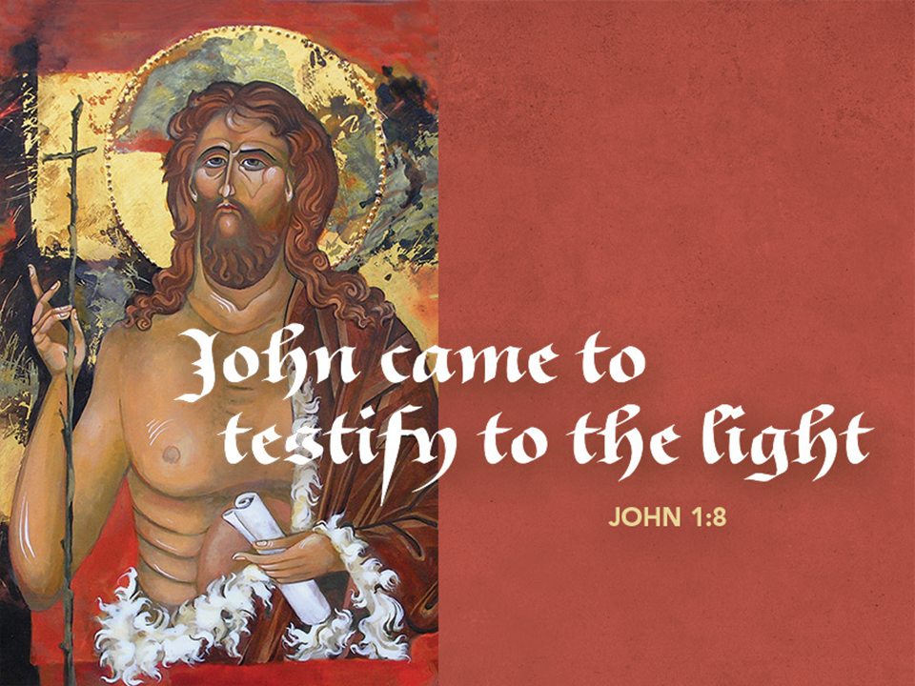
Complete Worship Folder

December 13, 2020

ASCENSION LUTHERAN CHURCH

8695 Gratiot Road Saginaw, MI 48609 (989)781-2170

Email address: ascensionlc@sbcglobal.net

Julie Bailey, Pastor

Sunday Worship 8:00am & 10:30am

Wednesday Worship 7:00pm

Third Sunday of Advent December 13, 2020
Welcome and Announcements

Lighting of Advent Wreath
We praise you, O God, for this victory wreath that marks our days of preparation for Christ’s advent.
As we light the candles on this wreath, strengthen our hearts as we await the Lord’s coming in glory.
Enlighten us with your grace, that we may serve our neighbors in need. Grant this through Christ our Lord,
whose coming is certain and whose day draws near.
Amen.

Call to Worship: Luke 1:46b-55
P: My soul proclaims the greatness of the Lord, my spirit rejoices in God my Savior,
C: for you, Lord, have looked with favor on your lowly servant. From this day all generations will call me blessed:

P: you, the Almighty, have done great things for me and holy is your name.
C: You have mercy on those who fear you, from generation to generation.

P: You have shown strength with your arm and scattered the proud in their conceit,
C: casting down the mighty from their thrones and lifting up the lowly.

P: You have filled the hungry with good things and sent the rich away empty.
C: You have come to the aid of your servant Israel, to remember the promise of mercy, the promise made to our forebears, to Abraham and his children forever.

Greeting
P: The grace of our Lord Jesus Christ, the love of God, and the communion of the Holy Spirit be with you all.
C: And also with you.

Prayer of the Day
P: Let us pray... Stir up the wills of your faithful people, Lord God, and open our ears to the words of your prophets, that, anointed by your Spirit, we may testify to your light; through Jesus Christ, our Savior and Lord, who lives and reigns with you and the Holy Spirit, one God, now and forever.
C: Amen.

First Reading: Isaiah 61:1-4, 8-11
¹The spirit of the Lord God is upon me,
because the Lord has anointed me;
he has sent me to bring good news to the oppressed,
to bind up the brokenhearted,
to proclaim liberty to the captives,
and release to the prisoners;
²to proclaim the year of the Lord’s favor,
and the day of vengeance of our God;
to comfort all who mourn;
³to provide for those who mourn in Zion—
to give them a garland instead of ashes,
the oil of gladness instead of mourning,
the mantle of praise instead of a faint spirit.
They will be called oaks of righteousness,
the planting of the Lord, to display his glory.
⁴They shall build up the ancient ruins,
they shall raise up the former devastations;
they shall repair the ruined cities,
the devastations of many generations.
⁸For I the Lord love justice,
I hate robbery and wrongdoing;
I will faithfully give them their recompense,
and I will make an everlasting covenant with them.
⁹Their descendants shall be known among the nations,
and their offspring among the peoples;
all who see them shall acknowledge
that they are a people whom the Lord has blessed.
¹⁰I will greatly rejoice in the Lord,
my whole being shall exult in my God;
for he has clothed me with the garments of salvation,
he has covered me with the robe of righteousness,
as a bridegroom decks himself with a garland,
and as a bride adorns herself with her jewels.
¹¹For as the earth brings forth its shoots,
and as a garden causes what is sown in it to spring up,
so the Lord God will cause righteousness and praise
to spring up before all the nations.
L: The word of the Lord.
C: Thanks be to God!

Second Reading: 1 Thessalonians 5:16-24
¹⁶Rejoice always, ¹⁷pray without ceasing, ¹⁸give thanks in all circumstances; for this is the will of God in Christ Jesus for you. ¹⁹Do not quench the Spirit. ²⁰Do not despise the words of prophets, ²¹but test everything; hold fast to what is good; ²²abstain from every form of evil.
²³May the God of peace himself sanctify you entirely; and may your spirit and soul and body be kept sound and blameless at the coming of our Lord Jesus Christ. ²⁴The one who calls you is faithful, and he will do this.
L: The word of the Lord.
C: Thanks be to God!

P: The Holy Gospel according to John, the first chapter.
C: Glory to you, O Lord.

Gospel: John 1:6-8, 19-28
⁶There was a man sent from God, whose name was John. ⁷He came as a witness to testify to the light, so that all might believe through him. ⁸He himself was not the light, but he came to testify to the light.
¹⁹This is the testimony given by John when the Jews sent priests and Levites from Jerusalem to ask him, “Who are you?” ²⁰He confessed and did not deny it, but confessed, “I am not the Messiah.” ²¹And they asked him, “What then? Are you Elijah?” He said, “I am not.” “Are you the prophet?” He answered, “No.” ²²Then they said to him, “Who are you? Let us have an answer for those who sent us. What do you say about yourself?” ²³He said,
“I am the voice of one crying out in the wilderness,
‘Make straight the way of the Lord,’ ”
as the prophet Isaiah said.
²⁴Now they had been sent from the Pharisees. ²⁵They asked him, “Why then are you baptizing if you are neither the Messiah, nor Elijah, nor the prophet?” ²⁶John answered them, “I baptize with water. Among you stands one whom you do not know, ²⁷the one who is coming after me; I am not worthy to untie the thong of his sandal.” ²⁸This took place in Bethany across the Jordan where John was baptizing.
P: This is the gospel of our Lord.
C: Praise to you, O Christ.

Sermon

Hymn of Response: “Christ be our Light” Red Book #715
1 Longing for light, we wait in darkness.
Longing for truth, we turn to you.
Make us your own, your holy people,
light for the world to see.

Refrain
Christ, be our light!
Shine in our hearts.
Shine through the darkness.
Christ, be our light!
Shine in your church gathered today.

2 Longing for peace, our world is troubled.
Longing for hope, many despair.
Your word alone has pow'r to save us.
Make us your living voice. Refrain

3 Longing for food, many are hungry.
Longing for water, many still thirst.
Make us your bread, broken for others,
shared until all are fed. Refrain

4 Longing for shelter, many are homeless.
Longing for warmth, many are cold.
Make us your building, sheltering others,
walls made of living stone. Refrain

5 Many the gifts, many the people,
many the hearts that yearn to belong.
Let us be servants to one another,
signs of your kingdom come. Refrain

Text and music © 1993 Bernadette Farrell. Published by OCP Publications. All rights reserved.
Used by permission. One License #715124

Apostles’ Creed
I believe in God, the Father almighty,
creator of heaven and earth.
I believe in Jesus Christ, his only Son, our Lord.
He was conceived by the power of the Holy Spirit
and born of the virgin Mary.
He suffered under Pontius Pilate, was crucified, died, and was buried.
He descended into hell. On the third day he rose again.
He ascended into heaven, and is seated at the right hand of the Father.
He will come again to judge the living and the dead.
I believe in the Holy Spirit, the holy catholic Church,
the communion of saints, the forgiveness of sins,
the resurrection of the body, and the life everlasting. Amen.

The Prayers of the Children of God
Each petition ends…Hear us, O God,
Congregation responds…your mercy is great.

Offering Prayer
P: Let us pray... Generous God, you have created all that is, and you provide for us in every season.
Bless all that we offer, that through these gifts the world will receive your blessing. In the name of Jesus, Emmanuel, we pray.
C: Amen.

Lord’s Prayer
Our Father, who art in heaven, hallowed be thy name, thy kingdom come, thy will be done, on earth as it is in heaven. Give us this day our daily bread; and forgive us our trespasses, as we forgive those who trespass against us; and lead us not into temptation, but deliver us from evil. For thine is the kingdom, and the power, and the glory, forever and ever. Amen.

Blessing
P: The Creator of the stars bless your Advent waiting, the long-expected Savior fill you with love, the unexpected Spirit guide your journey, ☩ now and forever.
C: Amen.

Song: Angels and a Holy Night (SS video 3:02)

Dismissal
P: Go in peace. Prepare the way of the Lord.
C: Thanks be to God.

From sundaysandseasons.com. Copyright © 2020 Augsburg Fortress. All rights reserved. #SAS006501

