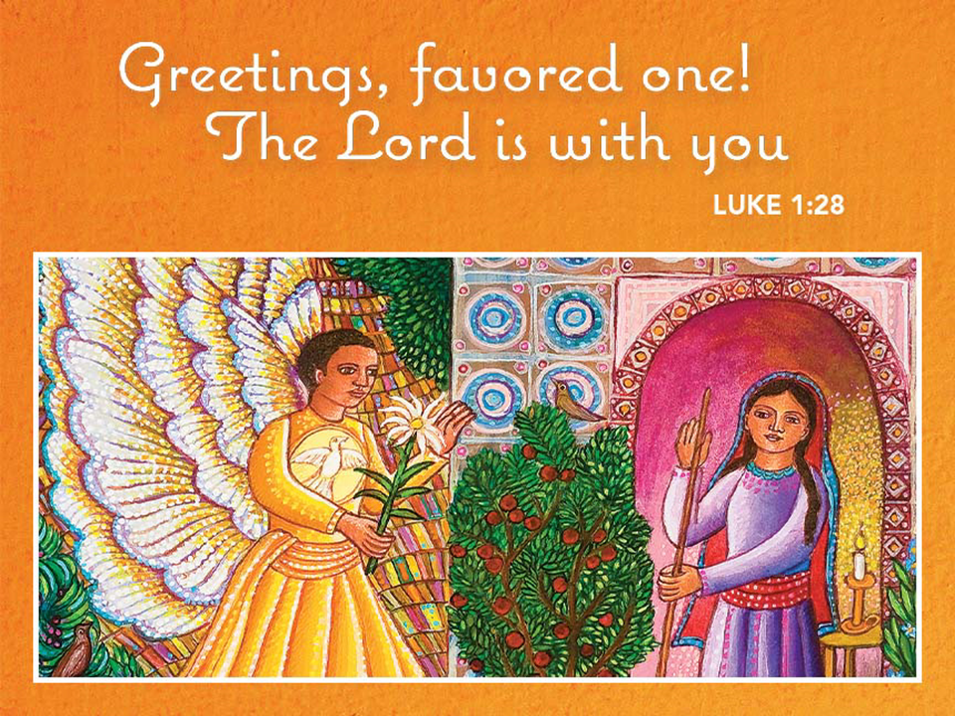
Complete Worship Folder

December 20, 2020

ASCENSION LUTHERAN CHURCH

8695 Gratiot Road Saginaw, MI 48609 (989)781-2170

Email address: ascensionlc@sbcglobal.net

Julie Bailey, Pastor

Sunday Worship 8:00am & 10:30am

Wednesday Worship 7:00pm

Fourth Sunday of Advent December 20, 2020
Welcome and Announcements

Lighting of Advent Wreath
We praise you, O God, for this wheel of time that marks our days of preparation for Christ’s advent. As we light the candles on this wreath, open our eyes to see your presence in the lowly ones of this earth. Enlighten us with your grace, that we may sing of your advent among us in the Word made flesh. Grant this through Christ our Lord, whose coming is certain and whose day draws near.
Amen.

Greeting
P: The grace of our Lord Jesus Christ, the love of God, and the communion of the Holy Spirit be with you all.
C: And also with you.

Prayer of the Day
P: Let us pray... Stir up the wills of your faithful people, Lord God, and open our ears to the words of your prophets, that, anointed by your Spirit, we may testify to your light; through Jesus Christ, our Savior and Lord, who lives and reigns with you and the Holy Spirit, one God, now and forever.
C: Amen.

First Reading: 2 Samuel 7:1-11, 16
¹Now when the king was settled in his house, and the Lord had given him rest from all his enemies around him, ²the king said to the prophet Nathan, “See now, I am living in a house of cedar, but the ark of God stays in a tent.” ³Nathan said to the king, “Go, do all that you have in mind; for the Lord is with you.”
⁴But that same night the word of the Lord came to Nathan: ⁵Go and tell my servant David: Thus says the Lord: Are you the one to build me a house to live in? ⁶I have not lived in a house since the day I brought up the people of Israel from Egypt to this day, but I have been moving about in a tent and a tabernacle. ⁷Wherever I have moved about among all the people of Israel, did I ever speak a word with any of the tribal leaders of Israel, whom I commanded to shepherd my people Israel, saying, “Why have you not built me a house of cedar?” ⁸Now therefore thus you shall say to my servant David: Thus says the Lord of hosts: I took you from the pasture, from following the sheep to be prince over my people Israel; ⁹and I have been with you wherever you went, and have cut off all your enemies from before you; and I will make for you a great name, like the name of the great ones of the earth. ¹⁰And I will appoint a place for my people Israel and will plant them, so that they may live in their own place, and be disturbed no more; and evildoers shall afflict them no more, as formerly, ¹¹from the time that I appointed judges over my people Israel; and I will give you rest from all your enemies. Moreover the Lord declares to you that the Lord will make you a house. ¹⁶Your house and your kingdom shall be made sure forever before me; your throne shall be established forever.

L: The word of the Lord.
C: Thanks be to God!

Second Reading: Romans 16:25-27
²⁵Now to God who is able to strengthen you according to my gospel and the proclamation of Jesus Christ, according to the revelation of the mystery that was kept secret for long ages ²⁶but is now disclosed, and through the prophetic writings is made known to all the Gentiles, according to the command of the eternal God, to bring about the obedience of faith—²⁷to the only wise God, through Jesus Christ, to whom be the glory forever! Amen.
L: The word of the Lord.
C: Thanks be to God!

P: The Holy Gospel according to Luke, the first chapter.
C: Glory to you, O Lord.

Gospel: Luke 1:26-38 (lumo)
²⁶In the sixth month the angel Gabriel was sent by God to a town in Galilee called Nazareth, ²⁷to a virgin engaged to a man whose name was Joseph, of the house of David. The virgin’s name was Mary. ²⁸And he came to her and said, “Greetings, favored one! The Lord is with you.” ²⁹But she was much perplexed by his words and pondered what sort of greeting this might be. ³⁰The angel said to her, “Do not be afraid, Mary, for you have found favor with God. ³¹And now, you will conceive in your womb and bear a son, and you will name him Jesus. ³²He will be great, and will be called the Son of the Most High, and the Lord God will give to him the throne of his ancestor David. ³³He will reign over the house of Jacob forever, and of his kingdom there will be no end.” ³⁴Mary said to the angel, “How can this be, since I am a virgin?” ³⁵The angel said to her, “The Holy Spirit will come upon you, and the power of the Most High will overshadow you; therefore the child to be born will be holy; he will be called Son of God. ³⁶And now, your relative Elizabeth in her old age has also conceived a son; and this is the sixth month for her who was said to be barren. ³⁷For nothing will be impossible with God.” ³⁸Then Mary said, “Here am I, the servant of the Lord; let it be with me according to your word.” Then the angel departed from her.

P: This is the gospel of our Lord.
C: Praise to you, O Christ.

Sermon

Hymn of Response: “My Soul Now Magnifies the Lord” Red Book #573
1 My soul now magnifies the Lord;
my spirit leaps, by joy possessed.
You keep me in your kind regard;
all generations call me blessed.

2 For you alone, O God of might,
have done amazing things for me.
Your mercy flows; your name like light
remains in time perpetually.

3 Your arm is strong; your strength is great.
You scatter those of proud intent,
and cast them down from high estate;
then give the low your nourishment.

4 You feed the hungry as your own;
the wealthy leave with empty hands.
You give your help to Israel;
your gracious promise always stands.

5 Sing glory to the Holy One,
give honor to the incarnate Word,
and praise the Pow'r of God most high,
from age to age by all adored.

Text © 1978 Lutheran Book of Worship, admin. Augsburg Fortress. Used with Permission. OneLicense #A-715124

Apostles’ Creed
I believe in God, the Father almighty,
creator of heaven and earth.
I believe in Jesus Christ, his only Son, our Lord.
He was conceived by the power of the Holy Spirit
and born of the virgin Mary.
He suffered under Pontius Pilate, was crucified, died, and was buried.
He descended into hell. On the third day he rose again.
He ascended into heaven, and is seated at the right hand of the Father.
He will come again to judge the living and the dead.
I believe in the Holy Spirit, the holy catholic Church,
the communion of saints, the forgiveness of sins,
the resurrection of the body, and the life everlasting. Amen.

The Prayers of the Children of God
Each petition ends…Hear us, O God,
Congregation responds…your mercy is great.

Offering Prayer
P: Let us pray... Generous God, you have created all that is, and you provide for us in every season.
Bless all that we offer, that through these gifts the world will receive your blessing. In the name of Jesus, Emmanuel, we pray.
C: Amen.

Lord’s Prayer
Our Father, who art in heaven, hallowed be thy name, thy kingdom come, thy will be done, on earth as it is in heaven. Give us this day our daily bread; and forgive us our trespasses, as we forgive those who trespass against us; and lead us not into temptation, but deliver us from evil. For thine is the kingdom, and the power, and the glory, forever and ever. Amen.

Blessing
P: The Creator of the stars bless your Advent waiting, the long-expected Savior fill you with love, the unexpected Spirit guide your journey, ☩ now and forever.
C: Amen.

Song: Hope Beyond all Hope (SS video 3:09)

Dismissal
P: Go in peace. Prepare the way of the Lord.
C: Thanks be to God.

From sundaysandseasons.com. Copyright © 2020 Augsburg Fortress. All rights reserved. #SAS006501

